**Search Engine Optimisation**

Search Engine Optimization, or SEO for short, is the practice of optimizing a website or online content to increase its visibility and ranking in search engine results pages (SERPs). With more and more businesses establishing an online presence, the competition to rank higher in search engines is becoming increasingly fierce. Therefore, it is crucial for businesses to invest in SEO in order to drive traffic to their website, increase conversions, and stay ahead of their competitors.

At Misc Archive, we understand the importance of SEO for businesses of all sizes. Our team of experienced SEO specialists utilizes a data-driven approach to analyze your website's current performance and identify areas for improvement. We then develop a customized SEO strategy that is tailored to your business goals and budget.

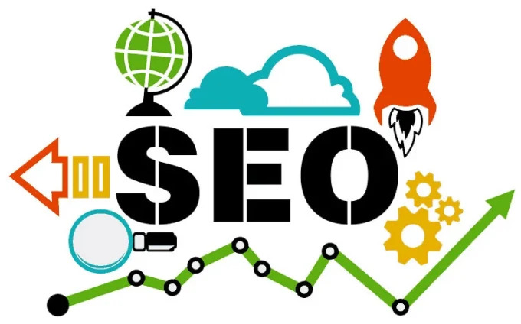

Our approach to SEO is centred around three key pillars:   
Technical SEO,  
on-page optimization,  
and off-page optimization.  
  
Technical SEO involves optimizing your website's technical infrastructure to ensure that it is easily crawlable by search engines. This includes ensuring that your website is mobile-friendly, has fast loading times, and has a clear site architecture.  
  
On-page optimization involves optimizing your website's content, including your website copy, meta descriptions, and headings. This allows you to make sure your content is properly structured and optimized for search engine crawlers to understand it and index it properly, helping you to improve your rankings in search engine results pages (SERPs)   
  
Off-page optimization involves building high-quality backlinks to your website, which can improve your website's authority and reputation in the eyes of search engines. By obtaining high-quality backlinks, search engine algorithms are able to recognise your website as a reliable source of information and rank it higher in their search results.

By choosing Misc Archive for your SEO needs, you can rest assured that you will receive high-quality, ethical SEO services that are tailored to your specific business needs. We pride ourselves on our transparent reporting and communication. We also stay up-to-date with the latest SEO best practices and algorithm updates, so you can be sure that you are receiving the most up-to-date SEO strategies.

In conclusion, SEO is a critical aspect of any business's digital marketing strategy, and choosing the right SEO partner is essential for achieving success in the highly competitive online landscape. Misc Archive has the experience, expertise, and dedication to help your business succeed with SEO, and we would love to help you achieve your business goals.

Contact us today to know more about how we can help you with your SEO needs.